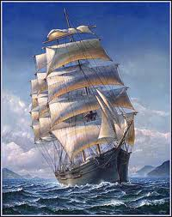
All aboard!
No. 30, Winter, 2022
All us Catholics on board together
An occasional Newsletter of encouragement for all Catholics in the Parish of St. Pius X, Heidelberg West.
More about SOLDIERS OF THE CROSS
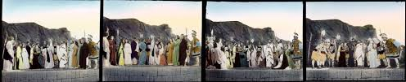
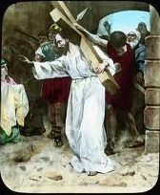
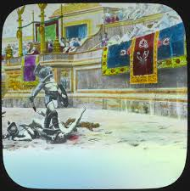
The 1899-1900 “Movie” presentation created in Melbourne by the Salvation Army … considered to be one of the very first “feature films” ever made.
(This explanation is taken directly from the site of the Australian Film and Television Archive: )

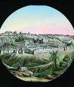
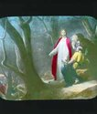
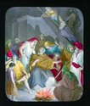
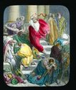
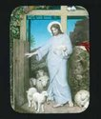
Soldiers of the Cross initially consisted of 200 glass slides and 15 films, each film running for approximately 90 seconds. The presentation took slightly over two hours. Much of the content for Soldiers was produced at the Salvation Army’s Australasian headquarters in Melbourne, and the larger scenes were shot at the Salvation Army Girls’ Home in Murrumbeena. It is likely that footage and slides from earlier Salvation Army and non-Australian productions were incorporated into the lecture. No movie films from the production have so far been found. What a most exciting find it would be to be able to watch some sequences from the original film sequences. Only the slides have been kept from the original presentation. And no written texts that went with the “lecture” have been found. What a pity!

ooooooooooooooooooooooooooooooooooooooooooooooooooooooooooooooooooooooooooooooooooooooooooooooo
A thoughtful MORNING PRAYER:
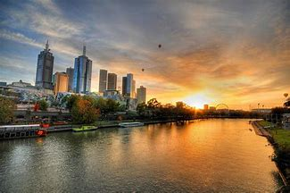
Good Morning, God
You are ushering in another day, untouched and freshly new,
So here I come to ask of you, God, if you’ll renew me too.
Forgive the many errors that I made yesterday, and let me try
Again, dear God, to walk close to thy Way …
But, Father, I am well aware I can’t make it on my own,
So take my hand and hold it tight, for I can’t walk alone.
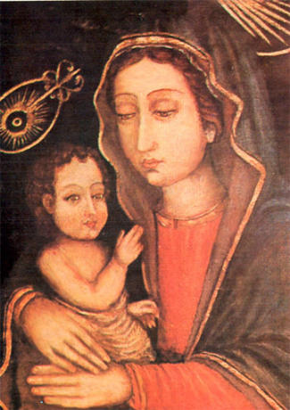
St. Luke’s portrait of Our Lady
By Br. Barry Lamb
OK! It’s only a legend. But it’s worth telling, I think.

A few railway stations south of the centre of Chennai in Southern India is a suburb called St. Thomas’ Mount. If you walk or take a motor rickshaw to the top you will find a modest chapel. On the right side of the sanctuary in a glass case about twice the size of A3 is a painting of Mary holding an infant/child Jesus. The legend is that it was painted by St. Luke.

There are classical paintings from the Renaissance showing St. Luke painting portraits of Our Lady but until recently I had not had my attention drawn to any particular painting that was said to have been painted by St. Luke. Since looking into this matter I have learned that there are said to be seven portraits of Our Lady by St. Luke. Google Images will give you an idea of some of the contenders. …But returning to the one in Chennai:

There is a very strong and ancient tradition that St. Thomas the Apostle moved to South-West India and then made his way over to the East coast to what is now Madras/Chennai. Wherever he went, it is told, he carried this painting around his neck like a scapular. The legend continues that Thomas was killed at this hill called St. Thomas Mount. Some several kilometres away, today, in the crypt of San Thome, the Cathedral of Chennai, is a tomb venerated as the resting place of St. Thomas’ remains. (Another legend)

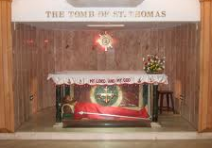
Another part of the legend is that when efforts were made to “touch up” the painting by an artist commissioned to do so, the “new” paint did not take. The painting defied alteration.

So there it is! And even with the most wonderful Marist Brothers’ education by a number of very saintly men I was never told this story. I was told the story of “the Holy House of Loretto”, but never of the painting on display for all to see in southern Chennai of Mary and Jesus “painted by St. Luke”!
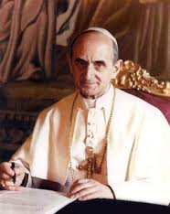
ooooooooooooooooooooooooooooooooooooooooooooooooooooooooooooooooooooooooooooooooooooooo
Earlier Pope shocked many with his words
Dear Reader, prepare to be shocked yourself!
For many years the Church spoke out against COMMUNISM. And many people were happy about that. But when Pope Paul VI spoke about aspects of CAPITALISM and the obligations of EVERYONE to care for those who don’t have enough to live on … he was condemned by some as being a Communist himself! See what you think. Here are some sentences from his famous letter Popolorum Progressio, written in 1967:
“Thus, as all men follow justice and unite in charity, created goods should abound for them on a reasonable basis" All other rights whatsoever, including those of property and of free commerce, are to be subordinated to this principle.

"If someone who has the riches of this world sees his brother in need and closes his heart to him, how does the love of God abide in him?."[St. Ambrose] It is well known how strong were the words used by the Fathers of the Church to describe the proper attitude of persons who possess anything towards persons in need. To quote Saint Ambrose: "You are not making a gift of your possessions to the poor person. You are handing over to him what is his. For what has been given in common for the use of all, you have arrogated to yourself. The world is given to all, and not only to the rich". That is, private property does not constitute for anyone an absolute and unconditioned right. No one is justified in keeping for his exclusive use what he does not need, when others lack necessities. In a word, "according to the traditional doctrine as found in the Fathers of the Church and the great theologians, the right to property must never be exercised to the detriment of the common good.

But it is unfortunate that on these new conditions of society a system has been constructed which considers profit as the key motive for economic progress, competition as the supreme law of economics, and private ownership of the means of production as an absolute right that has no limits and carries no corresponding social obligation.”
Just one tiny, beautiful section of our own Darebin Creek – photo taken from the net

A child was asked if he thought Noah would have done much fishing while on the Ark. His reply was: “How could he, with just two worms?"
An R.E. teacher said to her children, "We have been learning how powerful kings and queens were in Bible times. But, there is a Higher Power. Can anybody tell me what it is?" One child blurted out, "Aces!"
++++++++++++++++++++++++++++++++++++++++++++++++++++++++++++++++++++++++++++++++++++++++++++++++++++++++++++++++++++++++++++++++++++++++++++++++++++++
Story of a very famous prayer
It’s known as The Serenity Prayer. It has become famous because it is used by Alcoholics Anonymous around the world:
“God, grant me the serenity to accept the things I cannot change,
The courage to change the things I can,
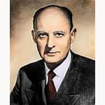
And wisdom to know the difference.”

There are a lot of stories about who composed the prayer. Those researching the prayer mention that the ancient Greek philosopher, Aristotle, said something very similar. Similar sentiments were found in the writings of St. Augustine who died in the year 430. Others say that St. Thomas Aquinas wrote something very like it. But its recent form, as shown above, is usually attributed to the great American Protestant theologian, author and preacher Reinhold Niebuhr (1892–1971 - pictured). It is said that he used words very similar to those above in a sermon in 1937 or thereabouts. Others found it to be a very short and thoughtful prayer that meant a lot to a lot of people. It grew in popularity in the 1940s.
The prayer was used in an obituary in the New York Herald Tribune early in 1942 and a member of AA showed others in his group who saw that it spoke boldly to them. They decided to print 500 copies of the prayer on small cards and distribute them to members.
Since then the prayer has been reproduced millions of times and has become one of the favourite prayers of all time, alongside The Lord’s Prayer and the famous Prayer of Saint Francis.
xxxxxxxxxxxxxxxxxxxxxxxxxxxxxxxxxxxxxxxxxxxxxxxxxxxxxxxxxxxxxxxxxxxxxxxxxxxxxxxxxxxxxxxxxxxxxxxxxxxxxxxxxxxxxxxx
Seven tips on dealing with moody people
1) Consider your options
2) Don't play their games
3) Don't reward moodiness
4) Just ask
5) Practical sympathy
6) Don't take it personally - it's them, not you
7) Take time out for yourself
[From an Article written by journalist, Mark Tyrrell.]
And while these headings need fuller explanation which the journalist gave in his article, they may serve as triggers for thought for those suffering from being close to moody people.
A Welcoming Home away from Home … in our own backyard!
This Home is situated locally in Donaldson St Ivanhoe, just in from Waterdale Rd., and provides low-cost accommodation for patients and their carers whilst attending appointments and receiving treatment at Melbourne hospitals. It is managed by Ryder - Cheshire Victorian Homes Foundation Inc.
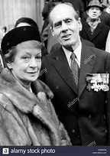
The founders of the Homes – about 400 spread through the world -- were the late Group Captain Lord Cheshire VC OM DSO DFC and the late Baroness Sue Ryder of Warsaw CMG OBE. Leonard Cheshire was Britain’s most highly decorated WW2 airman and Sue Ryder served in the Special Operations Executive in WW2 with responsibilities in Poland.

The Home was established 1981, is a not-for-profit organisation registered with the Australian Charities and Not-For-Profit Commission and operated by a Committee of Management who give their time on a voluntary basis. It comes under the umbrella of Ryder Cheshire Australia, which was founded in 1959, with the philosophy of the Founders, the foremost being the Relief of Suffering.
It comprises three apartment blocks with a total of 43 self-contained units, set in peaceful garden surrounds. Each apartment contains two or three single beds, an ensuite bathroom and a fully equipped kitchenette. (Meals and nursing are not provided.) Initial bookings must be made or confirmed by a doctor, liaison nurse, social worker, or other professional at the treating hospital.

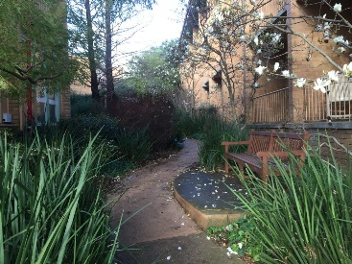
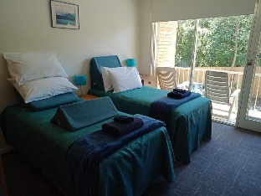
The Home does not receive government funding and apart from two staff members relies heavily on the efforts and generosity of many volunteers, and donors, who donate their time and services to keep the Homes running. And one of our parishoners, Peter Overton of Ivanhoe, has been on the Committee of Management there for a lengthy 40 years, and is currently President.

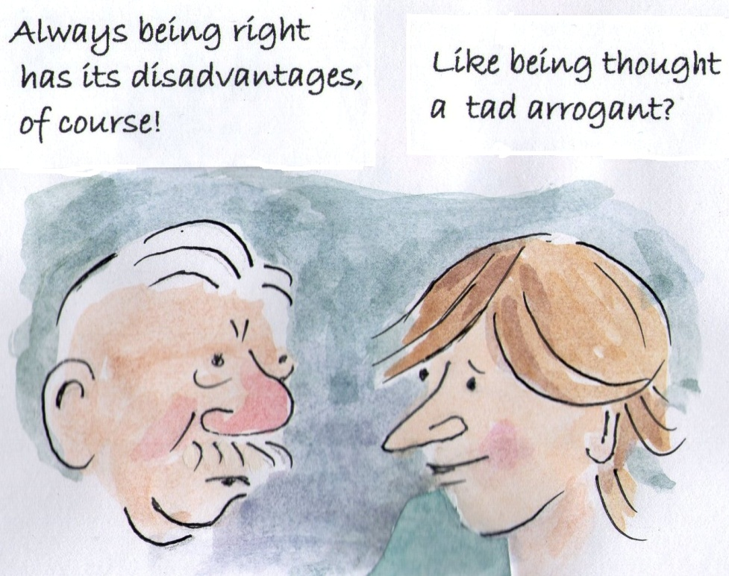
+++++++++++++++++++++++++++++++++++++++++++++++++

Yes! There are some GOOD things to recall!!
I made a list of the things I love
And the things that give me pleasure.
It grew and grew and I realise
That my life holds much great treasure.
So now if I’m feeling low
And the world seems so unkind
I glance along my treasured list
And leave my cares behind.
Contacts: St Pius X Catholic Parish Heidelberg West
Father Wayne Edwards: St Pius X Presbytery 419 Waterdale Rd., Heidelberg West 3081
Tel: 9457 5794 Fax: 9457 1036; stpiusvic@bigpond.com

Exodus Community: 273 Liberty Parade, Heidelberg West, Tel: 9457 7593
School Principal: Barbara Gomez, Tel: 9457 3776 principal@spheidelbergwest.catholic.edu.au
Mass times: Saturday evening Vigil – 7.00pm; Sunday: 9.00am & 11.00am, (12.00 noon, Exodus Community, 273 Liberty Parade,)
Weekdays: Tuesday , Wednesday, Thursday, Friday, Saturday, 9.00am
Confessions and Rosary: After 9.00am Mass Saturday mornings
Church open for prayer: 8.30am – 4.00pm on school days only
Taize Prayer – Last Friday of each Month, 6.00-7.00pm.
All Aboard compiler/editor: Brother Barry Lamb. Email: barrylamb@hotmail.com or 9456 9641

